Combiner
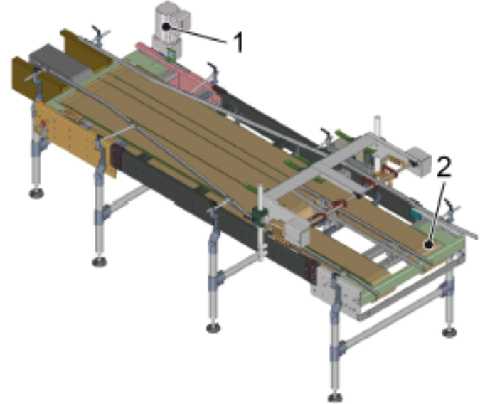
Layout
Figure 3-1: 2-to-1 combiner

Nº | Description
1 | Drive
2 | Conveyor belt

Function
The combiner combines two conveyor belts into one. Packs are conveyed via flat top chains.

